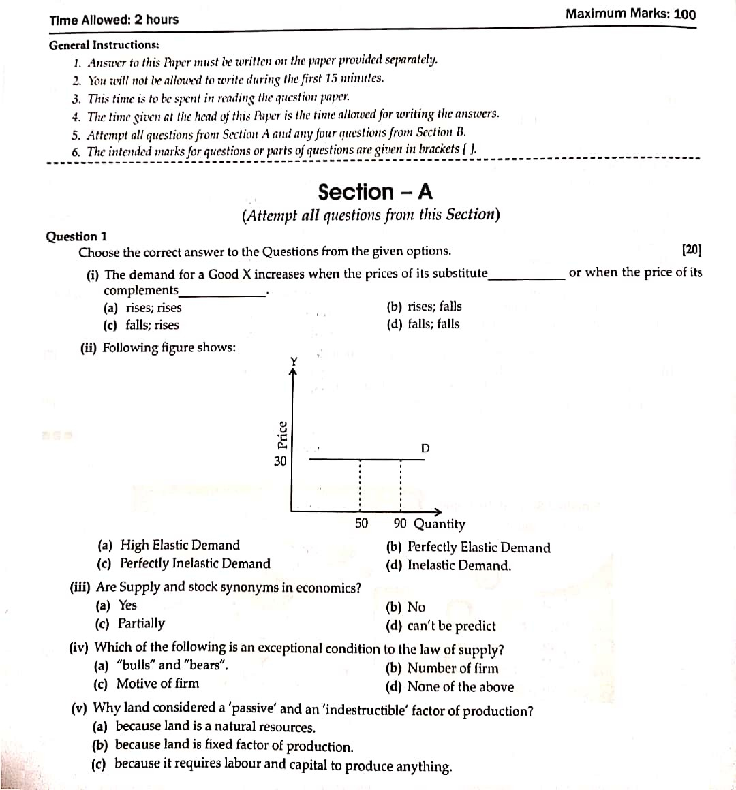**Economics Application**

(By Subrata Sir & group of ICSE and CBSE school teachers)

GUIDELINES

**Mock Paper – 2 (2023)**

